MCF3M Standard and Factored Forms Practice Test Name: _____________

Knowledge | R | Level 1 | Level 2 | Level 3 | Level 4
Able to factor and expand expressions |  | Limited success | Some success | Considerable success | A high degree of success

Please show all of your work!

1. Express each function in factored form.
a) f(x) = x² – 2x – 63 b) k(x) = 4x² – 81

c) g(x) = 3x² + 13x + 12 d) h(x) = 5x² – 5x – 60

2. Expand and simplify f(x) = (5x – 8)(x + 7) – 2(x + 4)². Then state the value of the y-intercept.

3. Express h(x) = 3(x – 2)² – 9 in standard form. Then state the value of the y-intercept.

Application | R | Level 1 | Level 2 | Level 3 | Level 4
Use of factoring to solve equations |  | Minor errors in solving both simple and complex equations | Applies factoring with skill to simple equations; difficulty with complex equations | Applies factoring with considerable skill to simple equations; minor errors in solving complex equations | Applies factoring with great skill to solve simple and complex equations

4. Factor and solve each equation.
a) 4y² – 28y = 0 b) 2x(x – 5) – 39 = (x + 3)² – 3x²

c) (a + 1)² + 2(a + 1) – 24 = 0

Communication | R | Level 1 | Level 2 | Level 3 | Level 4
Use of vocabulary |  | Uses vocabulary with limited effectiveness | Uses vocabulary with some effectiveness | Uses vocabulary with considerable effectiveness | Uses vocabulary with a high degree of effectiveness

5. Identify which equation each of the following graphs corresponds to. Explain how you know.

a) y = 2(x + 1)(x – 3) b) y = –2(x – 1)(x + 3) c) y = x² + 2x – 3 d) y = x² – 2x – 3

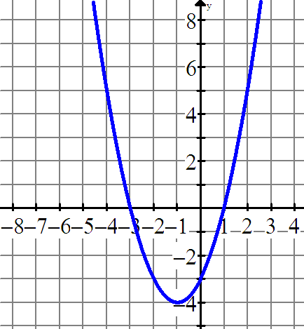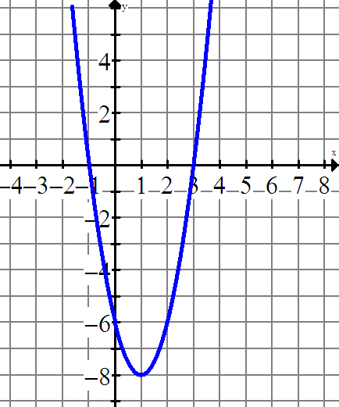
Graph 1: equation _____ Graph 2: equation _____
Reason: Reason:

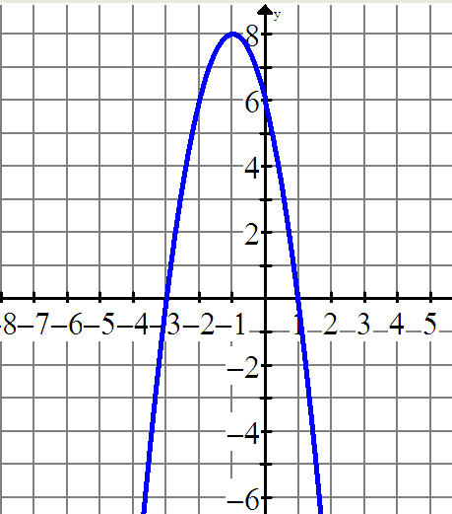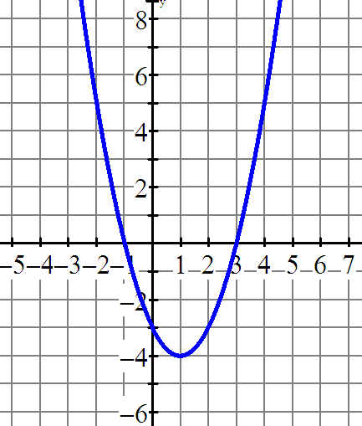
Graph 3: equation _____ Graph 4: equation _____
Reason: Reason:

Application | R | Level 1 | Level 2 | Level 3 | Level 4
Sketch graph of quadratic function in factored form. |  | Zeros are correct but vertex has errors. Sketch corresponds to this error. | Zeros and vertex are identified accurately, but sketch has minor errors OR Errors in zeroes, but vertex and sketch correspond to this error. | Zeros and vertex are identified accurately, and they are plotted accurately. | Zeros and vertex are identified accurately, and they are plotted accurately. Another point is identified accurately on the sketch.

6. Use the zeros and the vertex to sketch the function f(x) = –(x – 2)(x + 4).
(Hint: Use “steps” to identify additional points.)

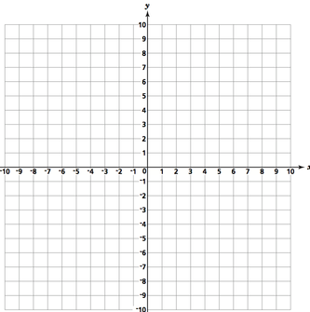

Application | R | Level 1 | Level 2 | Level 3 | Level 4
Solves problems arising from real world applications, given the algebraic representation of a quadratic function. |  | Applies the problem solving process with limited skill. | Applies the problem solving process with some skill. | Applies the problem solving process with considerable skill. | Applies the problem solving process with great skill to answer all questions accurately.

7. A water balloon is catapulted into the air. Its height, h, in metres, after t seconds is given by

h(t) = –2t² + 8t + 10

a) What is the initial height of the balloon?

b) When does the balloon hit the ground?

c) What is the maximum height of the rocket?

d) State the domain and rage of this function.

TIPS | R | Level 1 | Level 2 | Level 3 | Level 4
Solves problems involving quadratic functions. |  | Applies the problem solving process with limited skill. | Applies the problem solving process with some skill. | Applies the problem solving process with considerable skill. | Applies the problem solving process with great skill.

3x – 1
x + 2

2x + 7

8. The area of the inner white rectangle is given as x(x + 2).

a) Find the simplified expression for the shaded area.
b) If the shaded area is 15 m², find the value of x.

